**Lab 2: First experiments with the LM741 opamp IC**

All question material is in blue. Please put your answers in black color fontIn this assignment we will introduce you to the LM741 opamp IC. You will learn how to reliably make connections and build circuits around this IC. We will use the LM741 for many experiments during the rest of the semester, so make sure that at the end of this lab, you are thoroughly familiar with the procedure for making circuit connections to the LM741

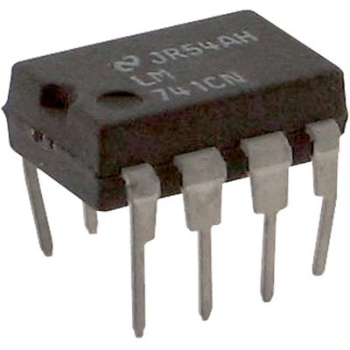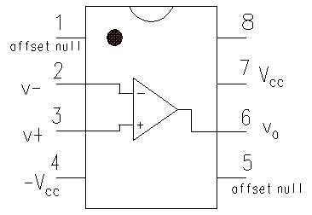

Fig 1: Picture and pinout of LM741

**“Golden” rules of opamp:**

1. Negligible current into

Fig 1 shows a picture and the pin diagram of the LM741 opamp

Note the numbering of pins as viewed from the top, with the semicircular notch facing up. You must always remember this when connecting the IC on a breadboard as shown in Fig 2

Fig 2: Connecting the LM741 on a breadboard

**WRONG!** Pins 1-4 and 5-8 of  
the IC will be shorted to each other!

**CORRECT:** Each pin has a separate horizontal breadboard trace. +VCC and –VCC are connected along the edge traces

+VCC

-VCC



**Question 1: “Dual” supply voltage Setup 3**741 opamp requires a dual voltage supply +Vcc and –Vcc (Fig 1)

* 1. **BASIC SETUP: 1**  
     You have two 9V batteries. How should you connect them so as to obtain such a dual supply +VCC and –VCC ? Is +9V and -9V adequate power supply for the opamp? (look up the datasheet!)  
     Make a circuit diagram here of your connection scheme:  
     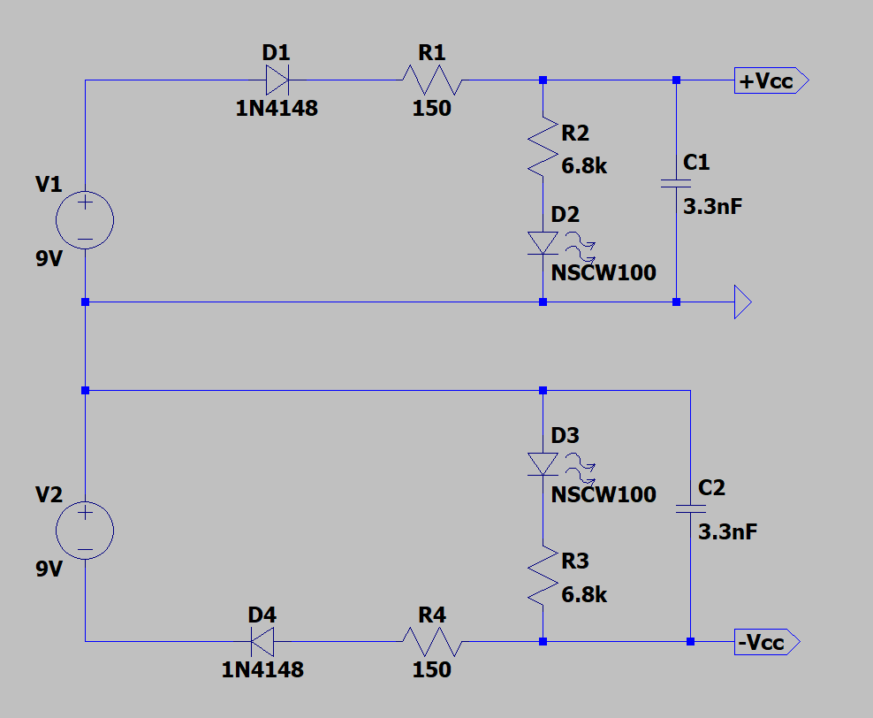
  2. **GROUND: 1**  
     As discussed extensively in PH231, every circuit must have a 0V GND reference node. In your ±VCC­ connection scheme of Question 1.1 above, which node should you take as the GND node?   
     The point between the negative of V1 and positive of V2.
  3. **PROTECTION/INDICATOR CIRCUIT 1**Similar to the 9V VCC circuit used in PH231, it would be nice to have a power on indicator, and a protection circuit to guard against instant discharge of the battery in case of bread-board short-circuits. Expand the design of witch, power indicator and protection circuit of PH231 for dual supply ±VCC. Draw your circuit here and implement it on your breadboard. **Now on your breadboard side rails, you will have 3 power lines, one each for +9V, –9V and GND. Check with DMM that you are getting the correct voltages at these power lines and label them for yourself clearly : you don’t want to reverse the ±9V connections to the opamp!  
       
     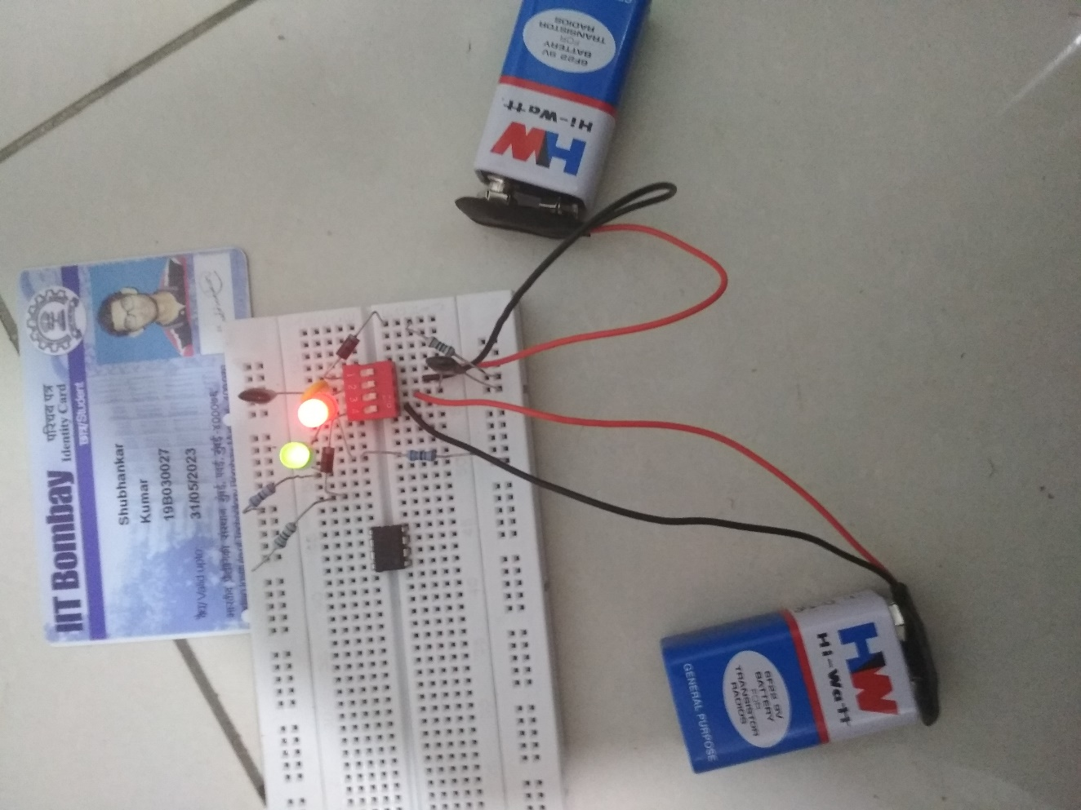**

**Question 2: Opamp POWER ON and Open Loop Test 6**

**2.1)** Mount the 741 opamp on your breadboard in the correct orientation as shown in Fig 2. Leave the inputs **disconnected** and the power **OFF.**   
Connect the red (signal) probe of the DSO to Vout from the opamp, black (GND) probe should be connected to your breadboard GND  
Set the DSO trigger mode to AUTO and choose a long time axis ~ 10ms/div.

Record here (with a photo) the steady state voltage observed at Vout and how   
**Vout changes when you turn the power ON:** **1**

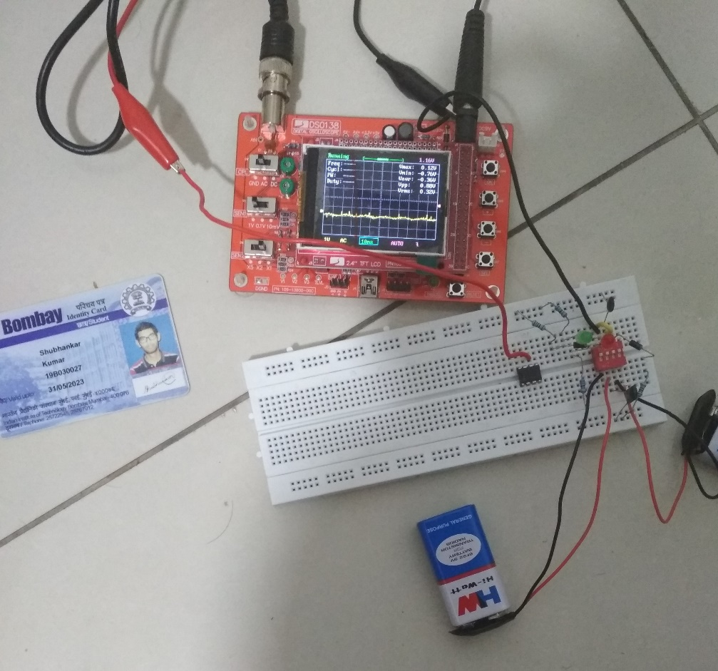

Explain your observation using the governing equation of opamp operation:  
 where is the “open loop gain”. **2**  
It may be useful to try this power ON/OFF test multiple times to check if your result is repeatable.

From the equation, it is clear that Vout = 0 when there is no input, i.e. V+ = V- = 0

**2.2)** To understand the measurements made in question 2.1 perform the following experiment to set voltages at two inputs V+­ and V- to definite values:  
Using a simple resistor divider set voltage at V- terminal to 1V  
Use a potentiometer as a variable resistor divider to set a variable voltage at V+ terminal  
Verify these voltages independently with the DMM as you connect them to the V+ and V- terminals.

What do you observe at Vout using the DMM as you vary V+ from below 1V to above 1V? Record your observations here: **2**

V+ = 3.3V, then Vout = 3.1V

V+ = -0.36V, then Vout = 0.06V

Using a graphic arrow, indicate where V+­ (as measured with DMM) rises from below 1V to above 1V. Are you able to accurately correlate your V+ setting to the observed transition in Vout? Why not? **1**

(You’d have to be a brave and patient experimenter to record in steps of μV! )

No, V+ cannot be correlated to the observed transition in Vout.

**Question 3: Opamp with feedback 11**From the experiments in question 2 it should be clear that an opamp running in “open loop” is a nearly useless device.

**3.1:**  Reconfigure your circuit connections of question 2 as per the following diagram (not all wiring to ±VCC and DSO probes is shown).   
Note that the opamp being a complex active IC requires it’s ±VCC power inputs to be bypassed by large electrolytic capacitors (choose 10 - 47μF) depending on availability. Make sure to connect each capacitor with its negative to a node that is at a *lesser* potential always than it’s positive terminal – else you are liable to suffer a little ‘poof’ event on your breadboard!

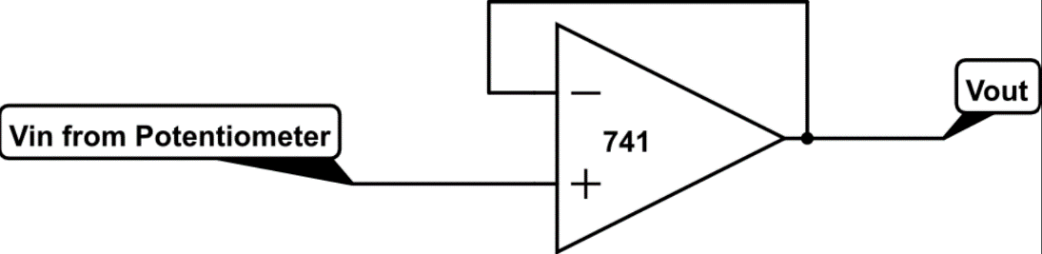 Now the fixed resistor divider at V– is no longer required.

Note that by convention, the opamp schematic symbol is drawn with V– (“inverting” input) above and V+ (“non-inverting” input) below.

**3.1.1)** Apply the governing equation of opamp operation with to work out the relation between Vout and Vin in the above circuit **2**

We have, . Now, Vout = V-

(G+1)Vout = G

If G >> 1, then G+1 ~ G. Hence, Vout = Vin

**3.1.2)** Try the above circuit with a four different values of potentiometer setting for different values of Vin and observe the corresponding Vout. Measure both Vin and V­out with your DMM. **2**

Do your readings match your expectations from 3.1.1 above?

|  |  |  |  |
| --- | --- | --- | --- |
| **R Divider 1 (ohms)** | **R Divider 2 (ohms)** | **Vin** | **Vout** |
| 100 | 7500 | 7.52 V | 6.73V |
| 200 | 2200 | 5.9203 V | 5.9215V |
| 510 | 1000 | 2.1625V | 2.1634V |
| 680 | 750 | 323.2mV | 324.1mV |

Yes, the readings are quite close (by rough interpolation).

**3.1.3)** This would be a good time to dust off the astable multivibrator circuit built as a Function Generator (FG) from PH231 lab. Set the peak-to-peak output of the FG to some reasonable value, Replace the DC voltage Vin from potentiometer of 3.1.2 and connect output of the FG to Vin of the opamp for a smoothly time-varying voltage waveform input. **6**

Record your photo readings of Vin (output of FG) and Vout from opamp here (two side-side-side) photos expected, indicating which is which. Else due to 3.1.2 it would be difficult to distinguish between them!

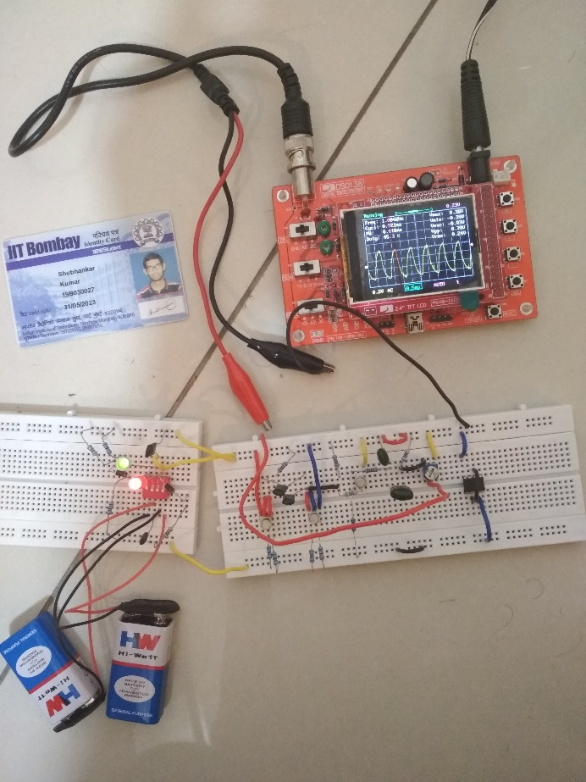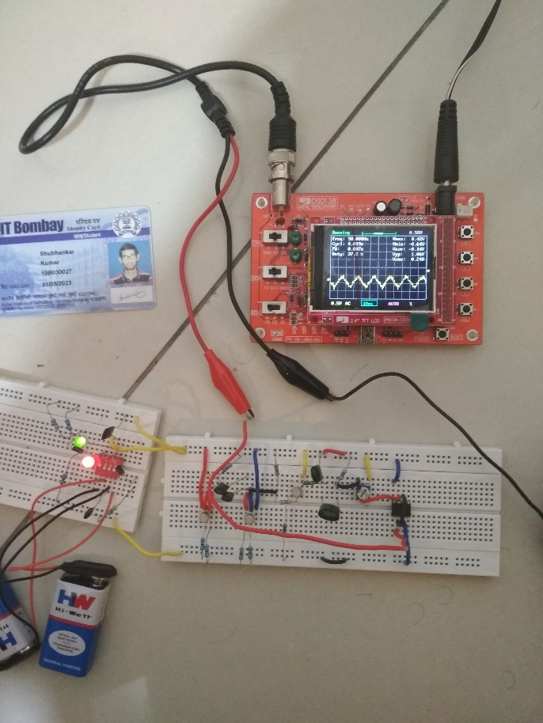

Output from FG Output from Op Amp

**Question 4: Analysis of Opamp with feedback**

Recall from our use of the Function Generator in PH231 that we often struggled with “loading” of its output by the input impedance of the circuit it was driving. The LTSpice simulation told us that for some value of the output 100kΩ potentiometer setting (say 30kΩ :70kΩ) the output amplitude should swing 0.3*3V = ±0.9V. But the experiments done in PH231 required a different potentiometer setting in practice due to impedance matching. Check if this is still the case. Set the output potentiometer of the FG to a precise value (as measured by DMM) and check its output with DSO before and after connecting it to the opamp circuit.

Does it change? If not, why not? **1**Note that we are only connecting to V+ input of the opamp – you will need to think about the impedance to a little more than trivial detail for 1 mark.

No, there is no change in the value before and after connecting it to the DSO as the input impedance of the opamp is either ways very high.